# Joel’s Shopping Cart code this is called “Abstract code”

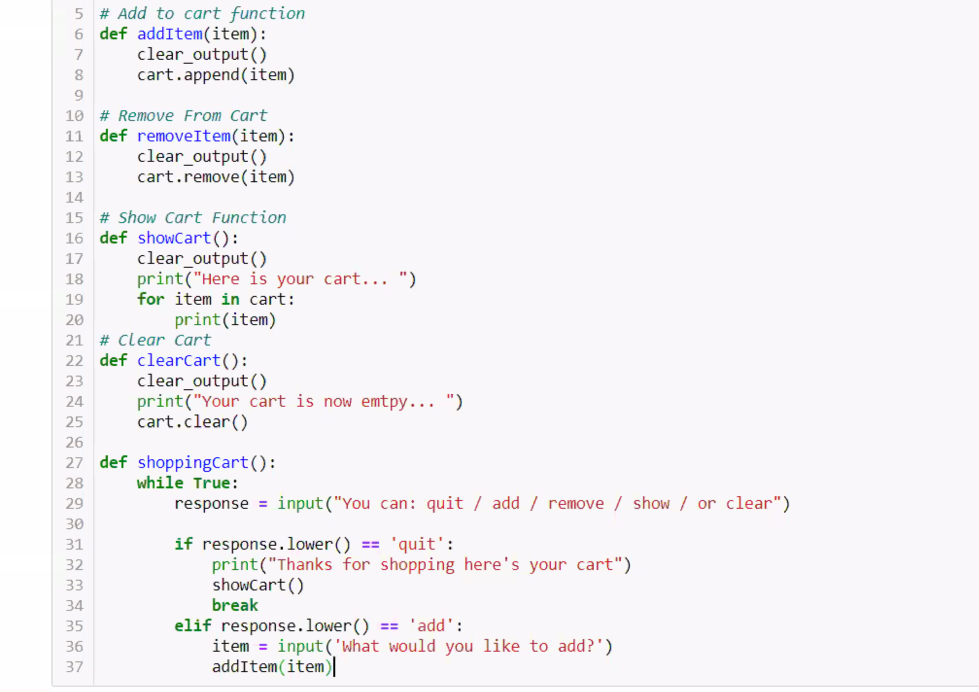

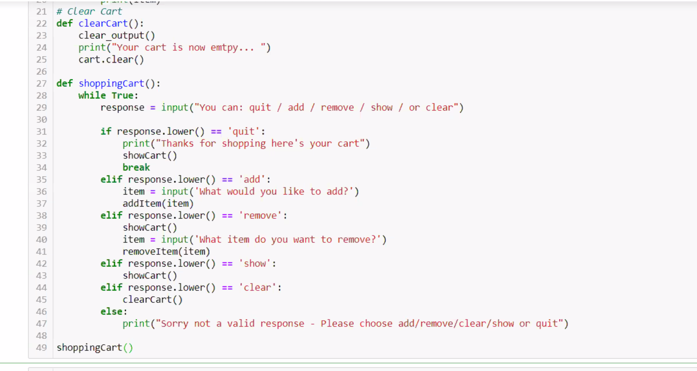

# Josh’s dictionary code for shopping cart

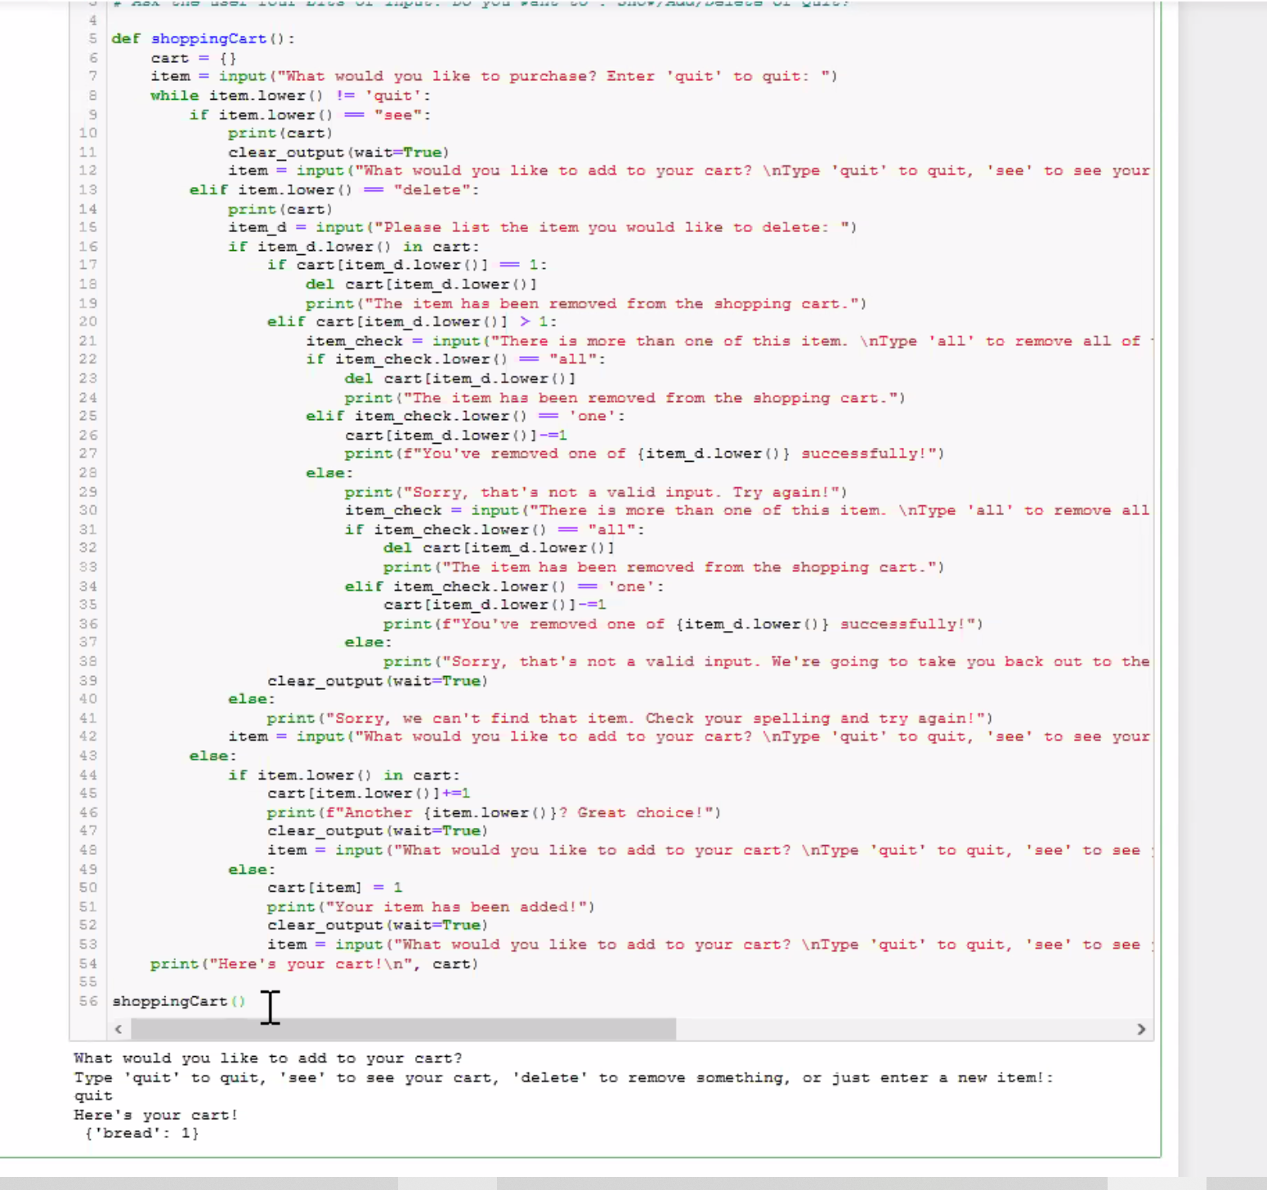

# Classical scoping is this

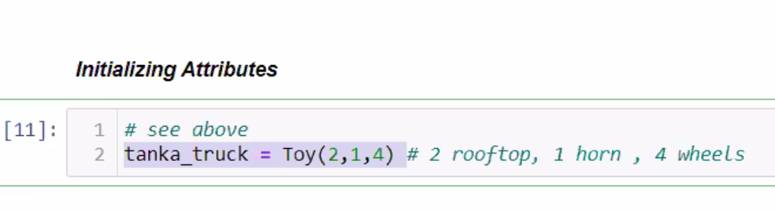

# Functional scoping is this

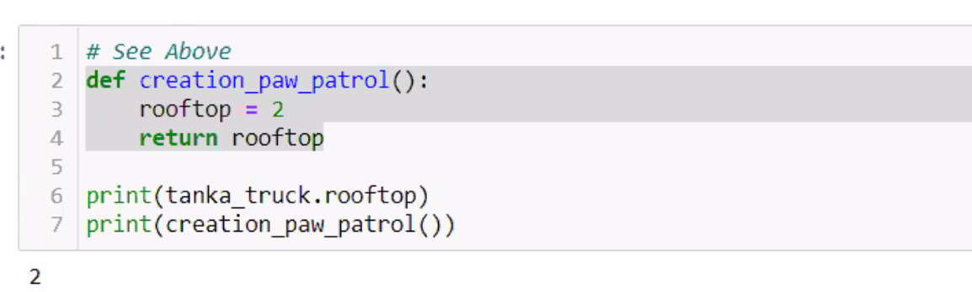

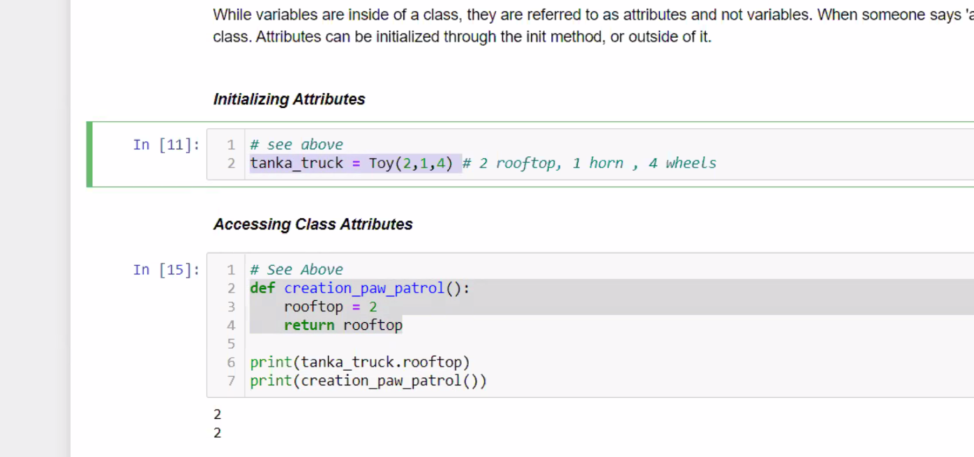



# Class Using constant attributes

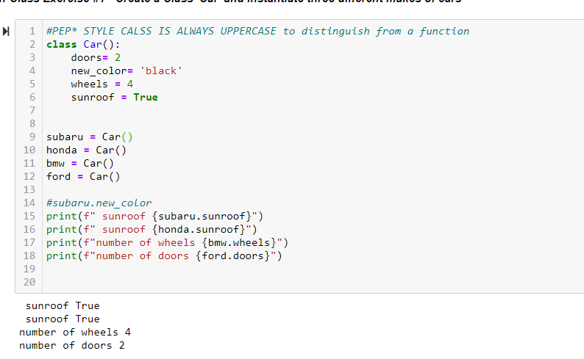

# Class Using constant and constructed attributes

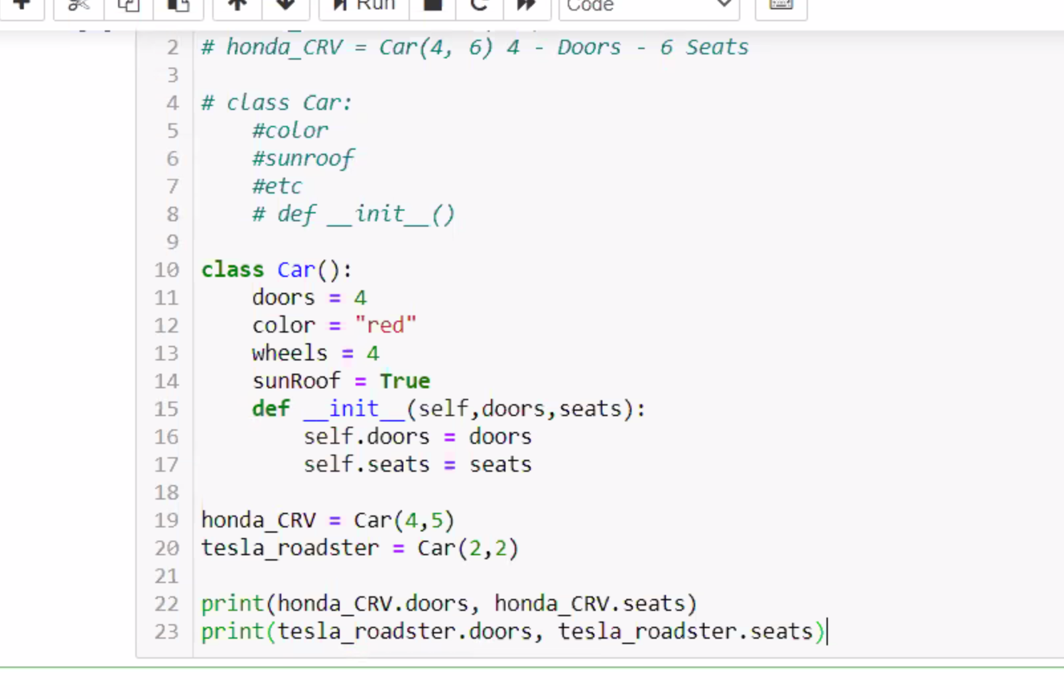

FIX THIS CODE IN MINe

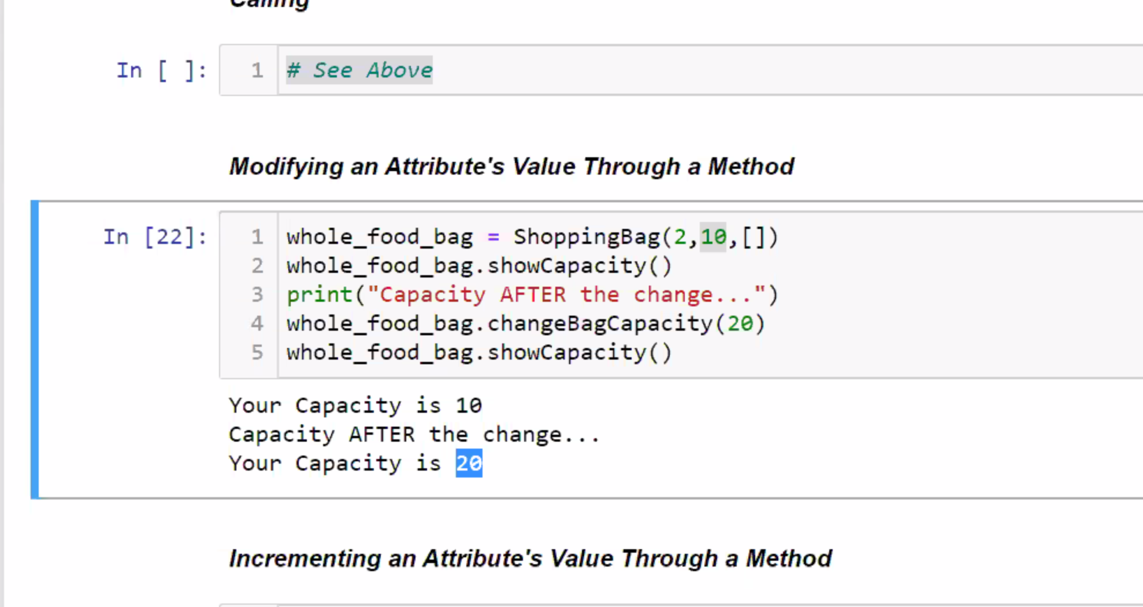

# JOEL’S exercise 3

